|  |  |  |  |  |  |  |
| --- | --- | --- | --- | --- | --- | --- |
| VILNIAUS KOLEGIJA  UNIVERSITY OF APPLIED SCIENCES  FACULTY OF ELECTRONICS AND INFORMATICS  Image result for viko logo | | |  | | | VILNIUS COLLEGE  Image result for viko logoFACULTY OF ELECTRONICS AND INFORMATICS |
|  | | |  | | |  |
| **HUMAN-COMPUTER INTERACTION DESIGN** | | |  | | | **INTRODUCTION TO INFORMATICS** |
| PRACTICAL ASSIGNMENT  EXAMPLES OF USER-FRIENDLY AND INCONVENIENT INTERFACES  6531BX028 PI18E | | |  | | | PRACTICAL ASSIGNMENT  SPOTIFY USER MANUAL  6531BX028 PI18E |
| STUDENT | DŽIUGAS PEČIULEVIČIUS | STUDENT | | DŽIUGAS PEČIULEVIČIUS |
| (SIGNATURE)  2/20/2019 | | |  | | | LECTURER |
| LECTURER | SVETLANA KUBILINSKIENĖ | (SIGNATURE)  10/17/2018 | | VIRGILIJUS KUKLIERIUS |
| (SIGNATURE)  2/20/2019 | | |  | | | 2018 |

2019

# CONTENT

EXAMPLE OF AN INCONVENIENT INTERFACE 4

**Page overview. Website: https://www.urbandictionary.com/** 4

**Our goal** 4

**What’s wrong with the page** 4

**Tools/ Log-In procedure** 6

**Results** 7

**Usability principles** 7

**Reflections** 8

EXAMPLE OF A USER-FRIENDLY INTERFACE 9

**Page overview. Website: https://www.alaskaair.com/** 9

**What’s great about the page** 9

**Our goal** 10

**Tools / Log-In procedure** 10

**Results** 11

**Usability principles** 11

**Picture 1 – Inconvenient interface page overview** 3

**Picture 2 - Browse button** 3

**Picture 3 - Upper tab** 4

**Picture 4 - Register button** 4

**Picture 5 - Log-In screen** 5

**Picture 6 - Profile menu** 5

**Picture 7 - Networks box** 6

**Picture 8 - Page "Footer"** 6

**Picture 9 – User-friendly page overview** 8

**Picture 10 - User- friendly page Footer** 8

**Picture 11 - Signing up** 9

**Picture 12 - Filling up information** 9

**Picture 13 - Profile drop-down** 10

# EXAMPLE OF AN INCONVENIENT INTERFACE

## **Page overview. Website:** [**https://www.urbandictionary.com/**](https://www.urbandictionary.com/)

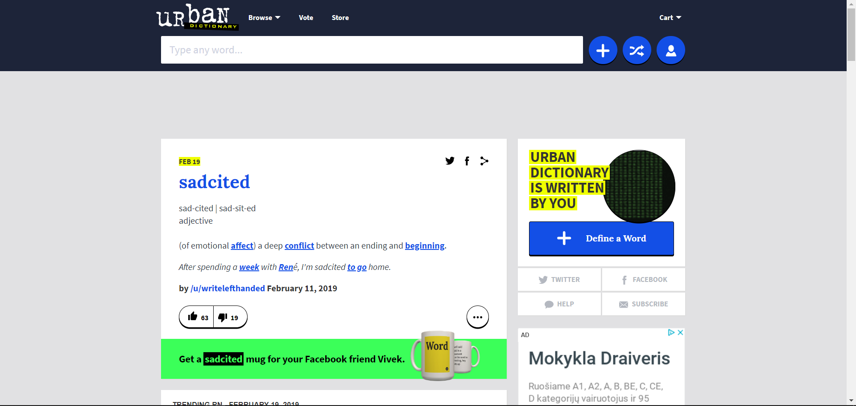

**Picture 1 – Inconvenient interface page overview**

## **Our goal**

**Our goal** is to create an account, log out and then log into our account.

## **What’s wrong with the page**

Firstly, once this page is turned on, I got lost, because I was expecting a register/login button at the top, but instead I have found a **‘Cart’** button which could actually be placed next to the **‘Store’** button or maybe even make a **‘Store’** button “drop-down” type of button and add the **‘Cart’** button there with other kind of buttons like contact, bank information.

Secondly, the **‘Browse’** button is really not that effective and lacks Substitutivity (flexibility in details of operations) in Picture 2, because it only gives us a drop-down menu of many letters and there’s no actual search function which is pretty inconvenient.

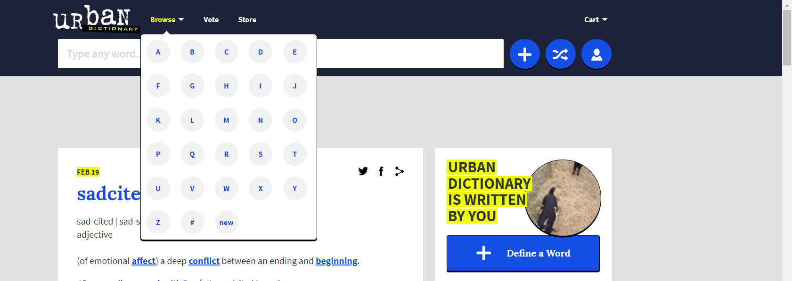

**Picture 2 - Browse button**

Also, on the left of a **‘Store’** button we could see a **‘Vote’** button and I’m not quite sure what it does, because the website is asking me to register into the website first.

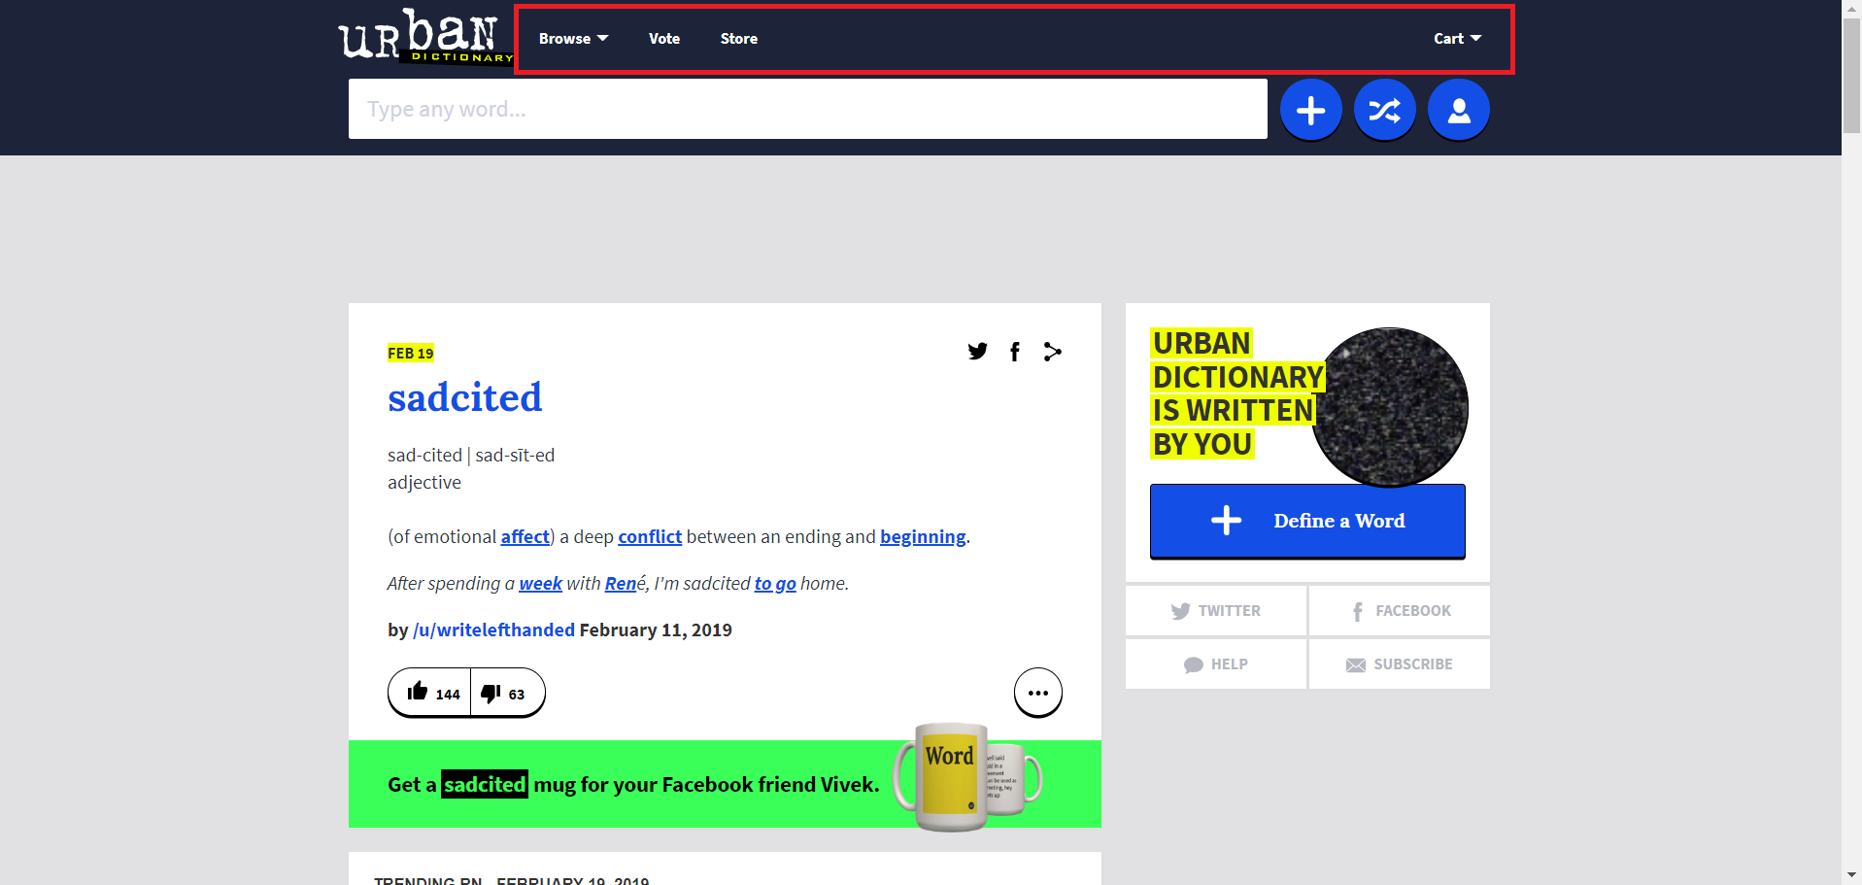

**Picture 3 - Upper tab**

Footer, it should be placed at the bottom with all the links that are not being visited frequently (Picture 8), and make it static so it stays at the bottom of the screen and doesn’t move while you scroll through the page.

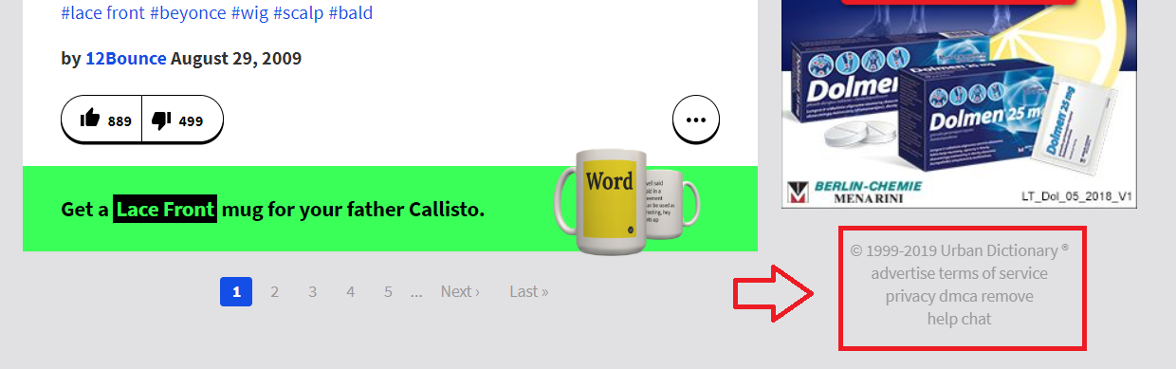

**Picture 8 - Page "Footer"**

## **Tools/ Log-In procedure**

So let‘s try to register now, appearantly this blue button in (Picture 4) is a **‘register‘** button.

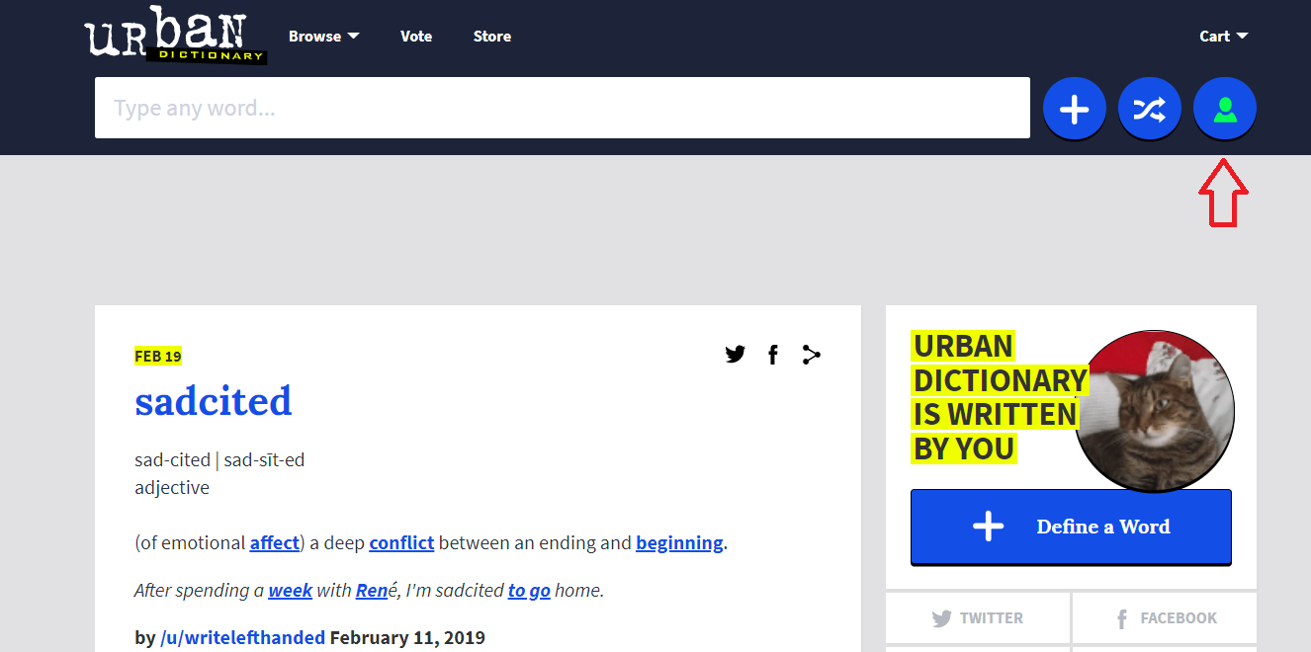

**Picture 4 - Register button**

Apparently, it only allows us to log-in with either our Google or Facebook accounts just as shown in Picture 5.

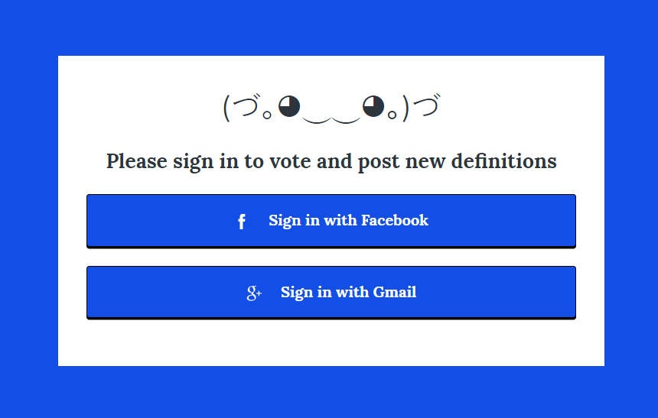

**Picture 5 - Log-In screen**

## **Results**

After logging in, the page doesn‘t change at all from how it looked back in (Picture 1), so it is really hard to tell if you‘re logged in or not. When clicked on the **‘Log-in‘** button, there‘s not much you can do, it is showed below in Picture 6:

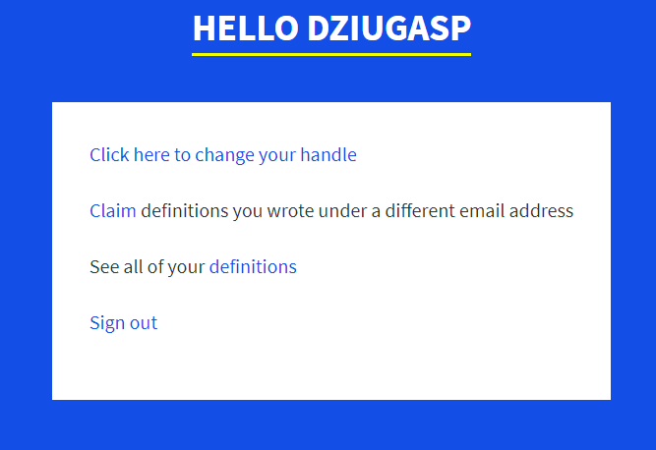

**Picture 6 - Profile menu**

Also, to make a page simple and usable for a user it would be a good idea to put all the networking information (Picture 7) to either very top of the page or put it at the very bottom of the page (called footer).

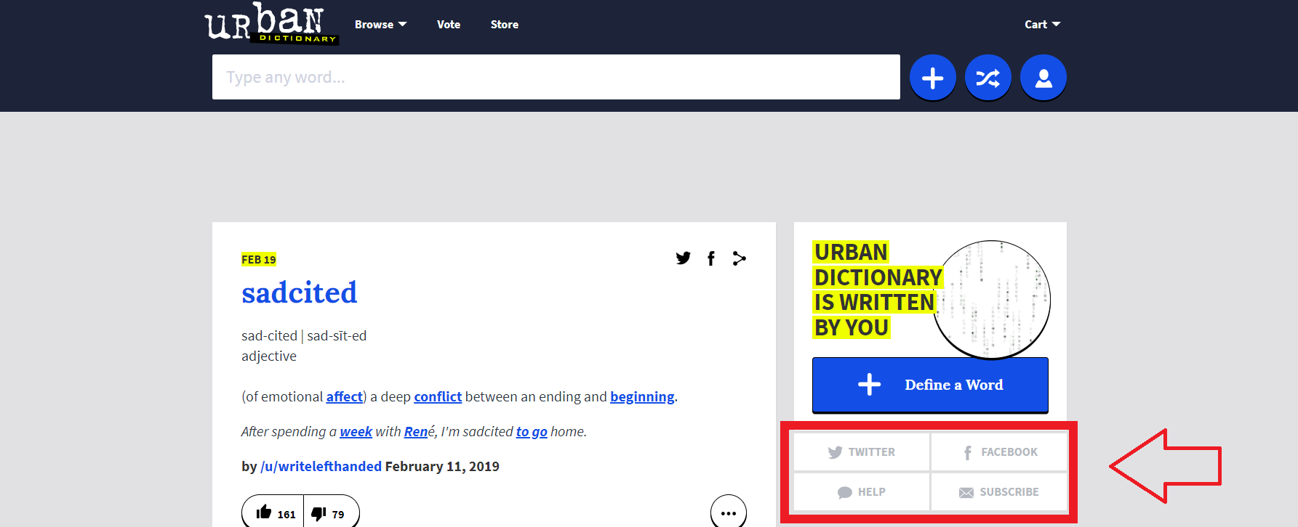

**Picture 7 - Networks box**

## **Usability principles**

Poorly executed principles:

* **Learnability** (**Familiarity** - The log in networking buttons are not in the usual location. **Consistency** – All the buttons are not in their usual location so it’s hard for the user to remember the location of all then buttons on this page.)
* **Flexibility** (**Substitutivity** – it doesn’t give us many options to input a word for example.

**Customizability** – there’s no way to edit user interface.)

* **Robustness** (**Task Confirmation** – It doesn’t ask for any confirmation when clicking on anything, even when registering or logging in.)

## **Reflections**

Website is inconsistent, confusing and difficult to use. It’s pretty hard to find the log in system. This could be easily solved by probably making 3 different buttons for registering, logging in and registering an account. This would make it easy to remember where everything related to the profile can be found.

# EXAMPLE OF A USER-FRIENDLY INTERFACE

## **Page overview. Website:** [**https://www.alaskaair.com/**](https://www.alaskaair.com/)

## 

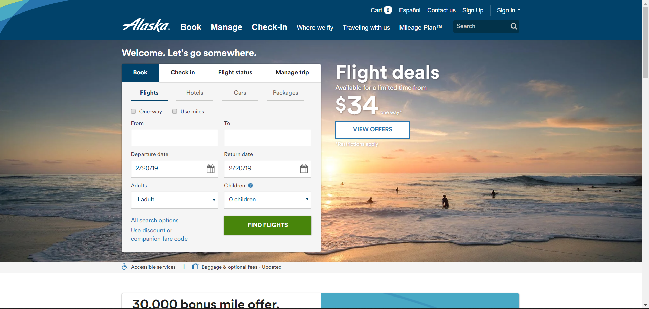

**Picture 9 – User-friendly page overview**

## **What’s great about the page**

Compared to the first page we talked about, this page is user-friendly and easy to use, all information is in their places where they belong to (Picture 10).

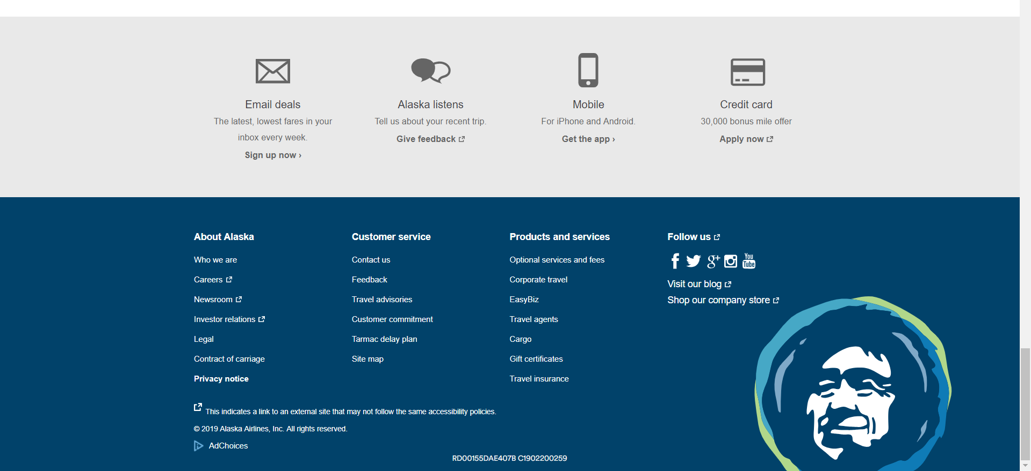

**Picture 10 - User- friendly page Footer**

## **Our goal**

**Our goal** is to create an account, log out and then log into our account.

## **Tools / Log-In procedure**

Firstly, when **‘Sign Up‘** button is clicked, you will want to click on „Sign up for a My account profile“ which is displayed in Picture 11.

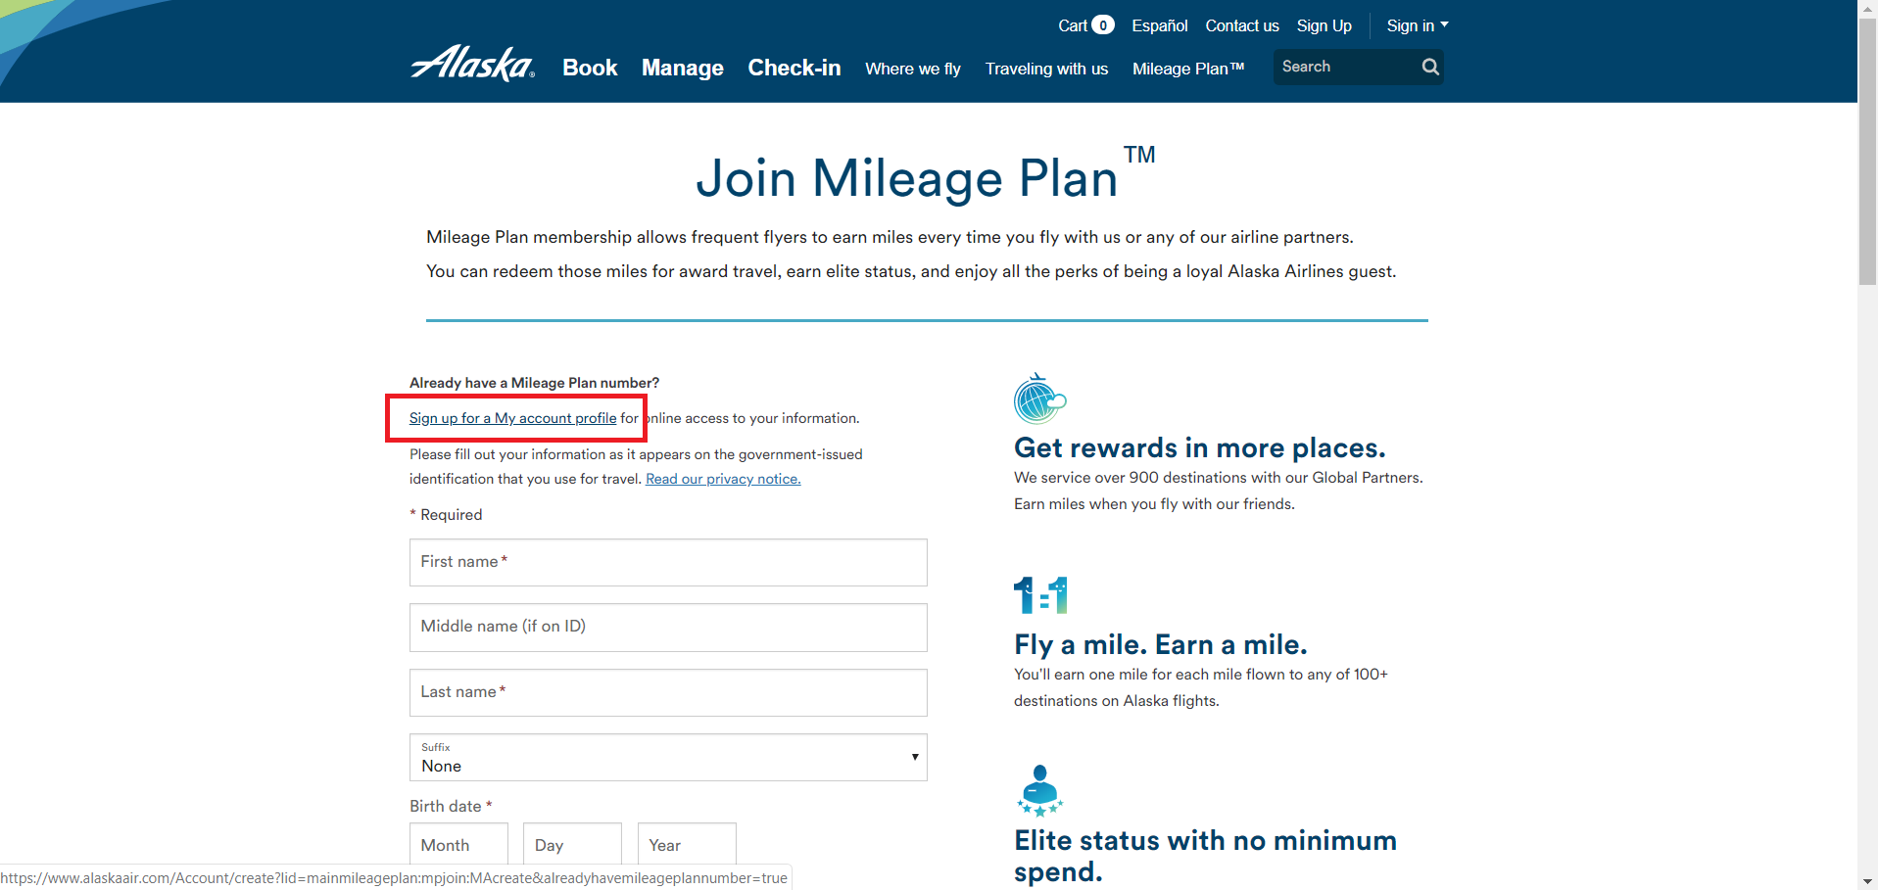

**Picture 11 - Signing up**

Then you will want to fill your contact information, and then click **‘Create an account‘** at the bottom (Picture 12).

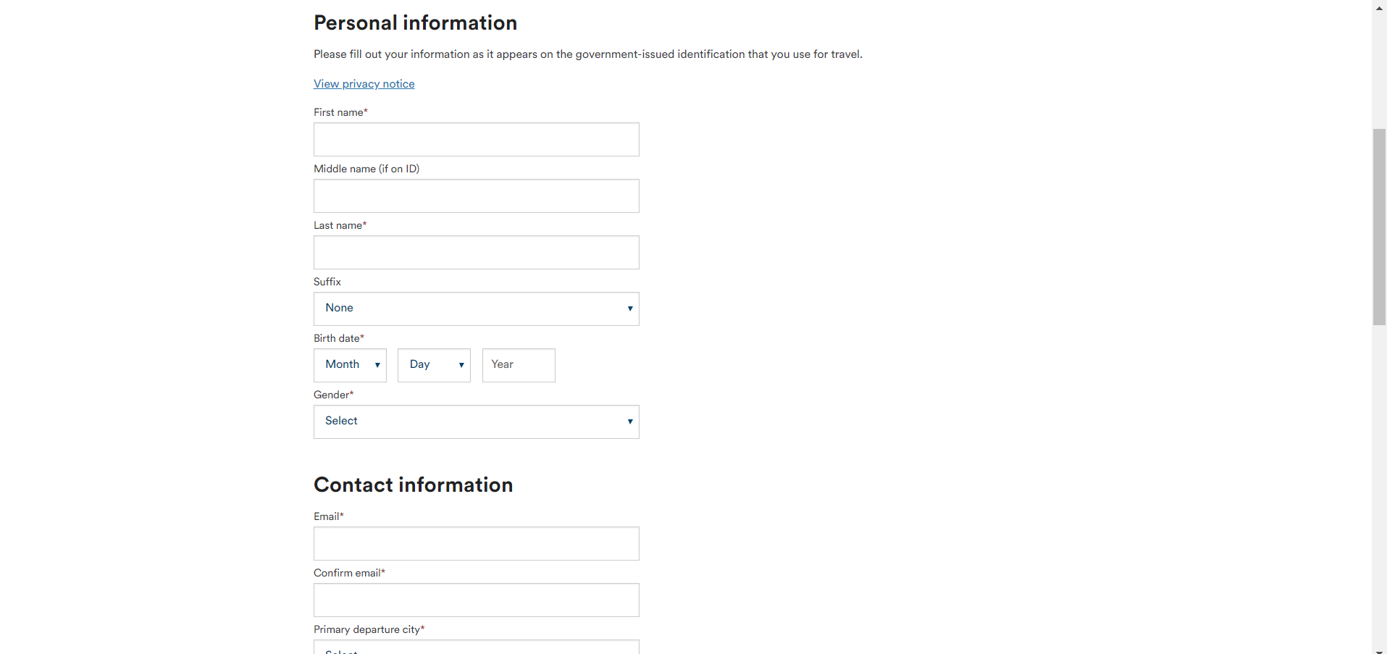

**Picture 12 - Filling up information**

## **Results**

After registering you should be able to access your account no problem!

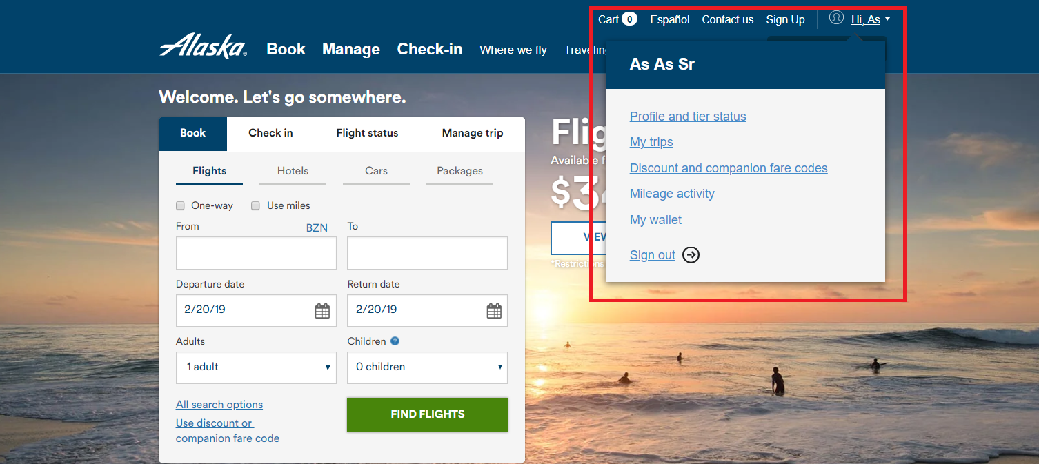

**Picture 13 - Profile drop-down**

## **Usability principles**

Poorly executed principles:

* **Learnability** (**Synthesizability** – Had problems registering an account. After clicking on **‘create an account’** it kept bringing me to a white screen with no error messages.)
* **Robustness** (**Recoverability** – did not get any messages helping me to resolve an error with registering an account.)

## **Reflections**

When designing the interface it was overlooked that the users would have to click few times to bring them a registration form. This can easily be solved by either by just bringing the main registering form after a users clicks on a ‘**Sign-up**‘ button.